**Odonate have been created by Bio Footwear Company in order to develop a line for the Tourism professional. We propose a range of single use product that respect the environment.**

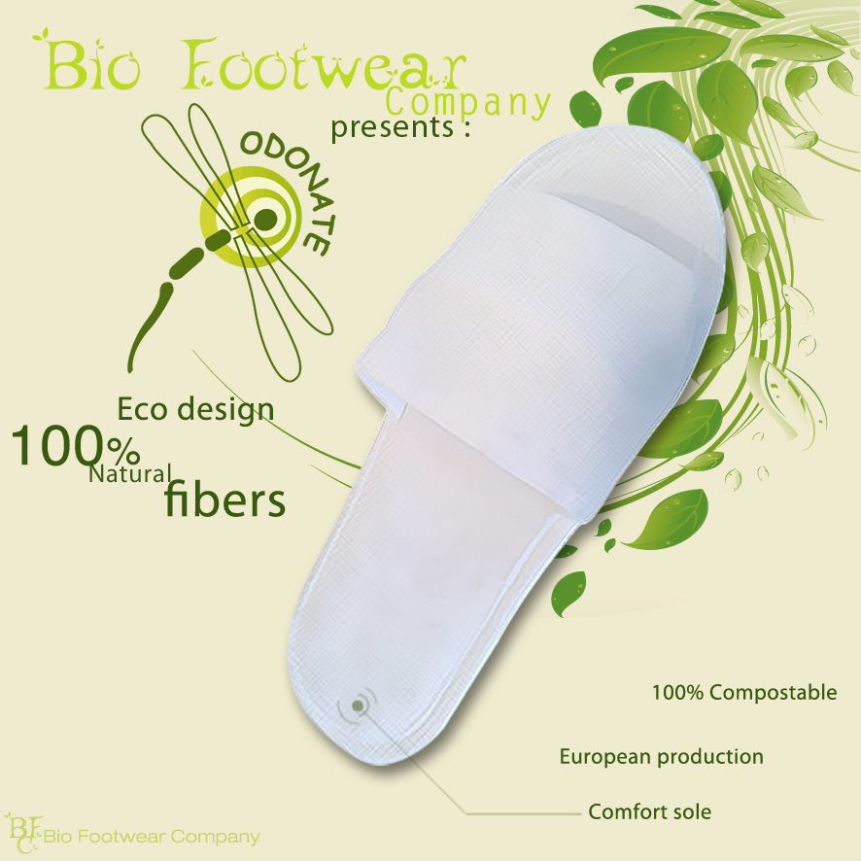

**Our Products, Our concept**

**100% Natural fibers**

**100% Biodegradable**

**100% Compostable**

Conform to the European standard EN13432 for the biodegradability

of products without any impact on the environment.

The fibers we are using have exceptional properties:

**Extrem comfort**

** Lightness feeling**

**Natural anti-bacterial action**

**Excellent permeability**

**Give your hotel an eco friendly attitude!**

Choosing products 100% Natural shows to your customers that you

participating to the respect of the environment, and permit to :

**Reduce the impact of your hotel on the environment**

**Contribute to the well-being & comfort of your customers**

**Communicate around your eco friendly engagement**

**Promote your hotel in an eco-responsible way**

**Help to get an ecological label**

**Follow the trend of sustainable development**